|  |  |
| --- | --- |
| **[Project] – External Document** |  |
| COMP6681001  Web Programming |
| Odd Semester Year 2022/2023 |

* Project Title

Movie List

* Introduction

Movie List is a famous movie website made by a famous computer science student. In that website, people can find information about the Famous Movie’s list. This website enables the users to add the movie to their watchlist.

* Report / Documentation

1. Login Page

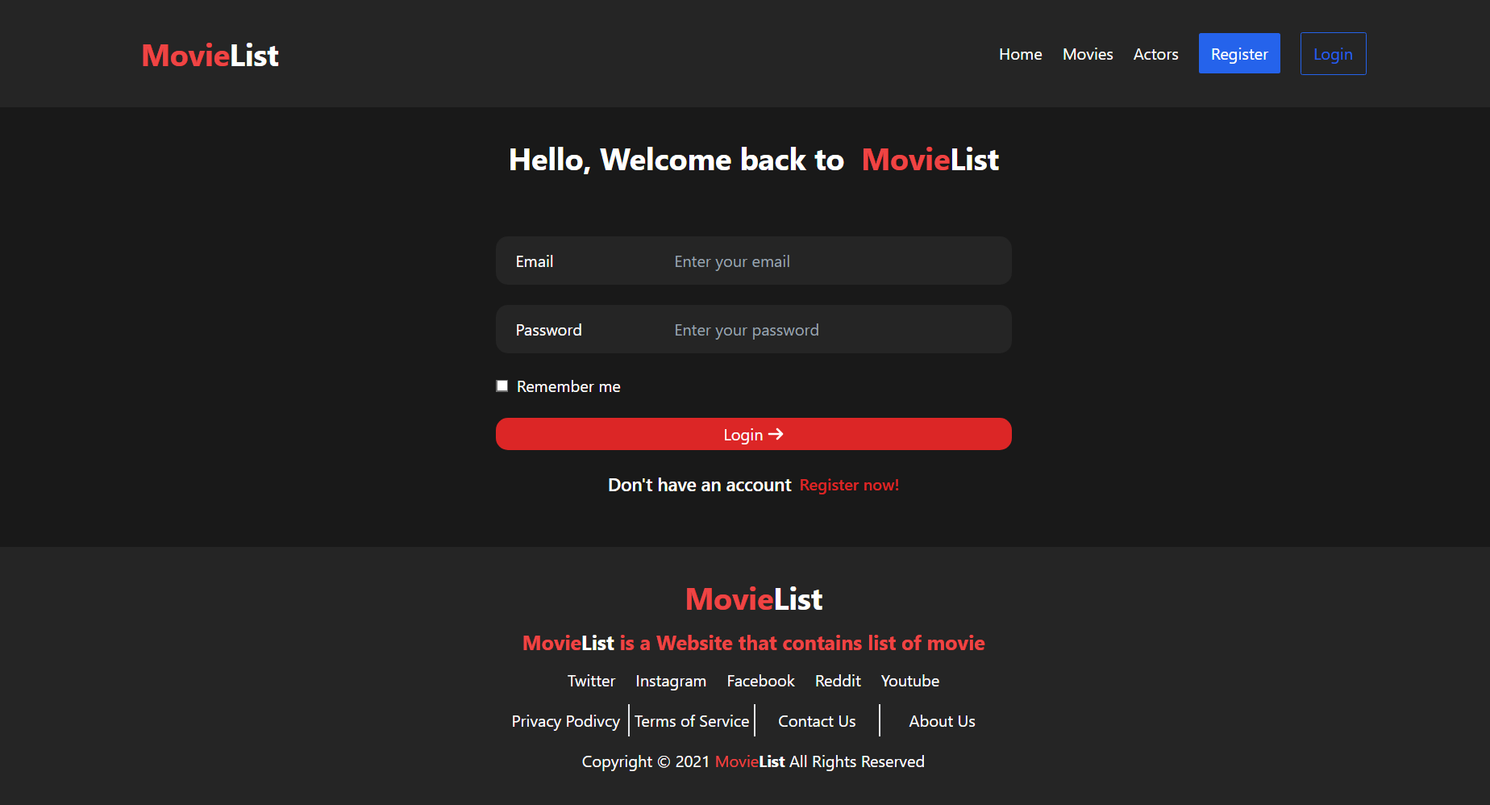

1. Register Page

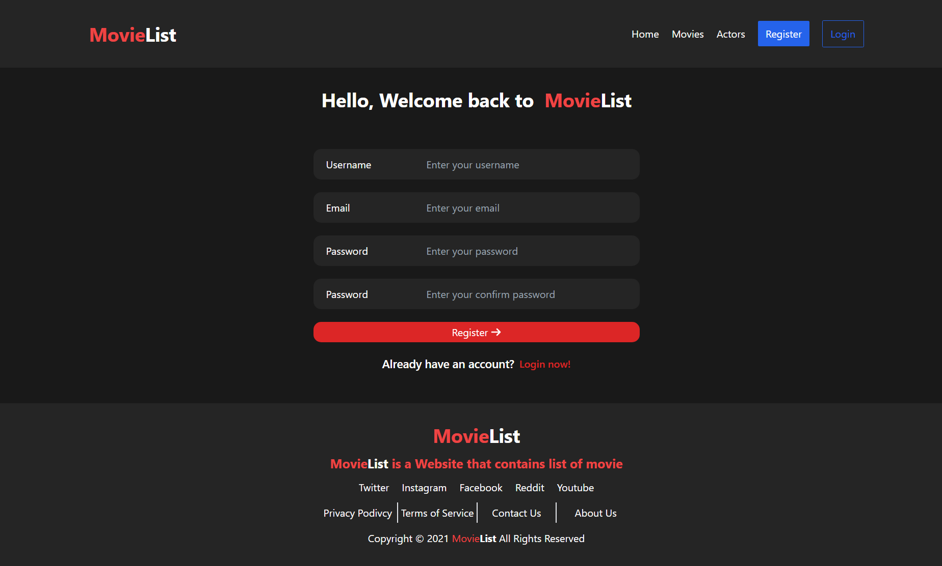

1. Home Page
   1. Guest

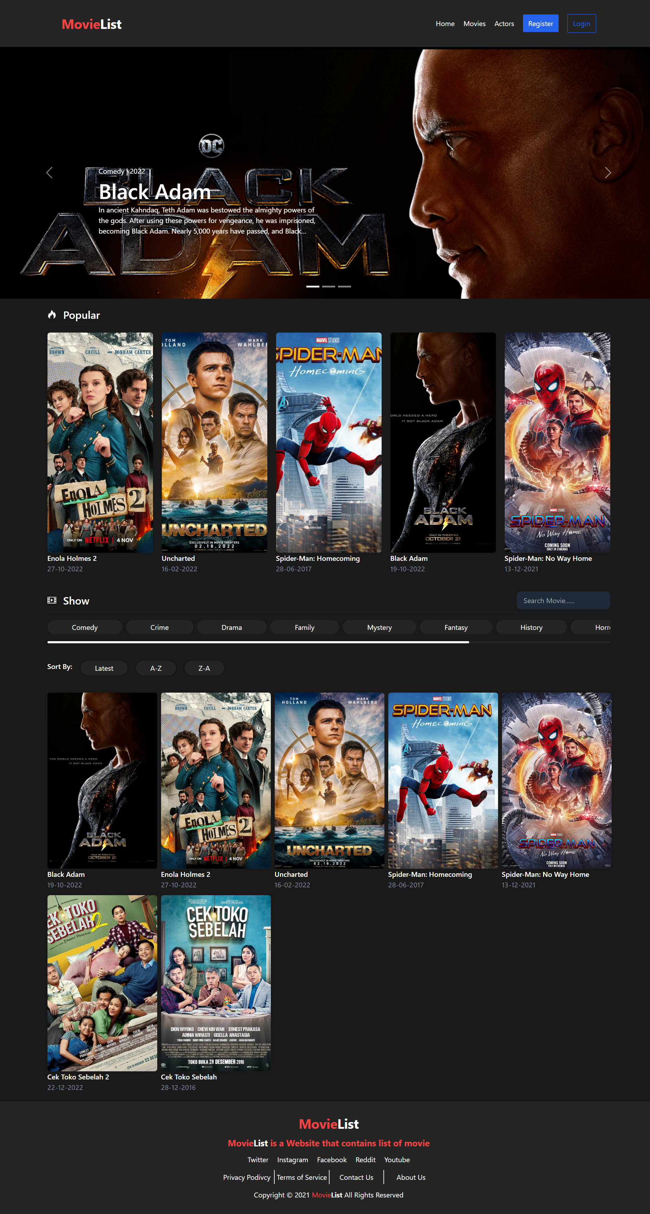

* 1. User

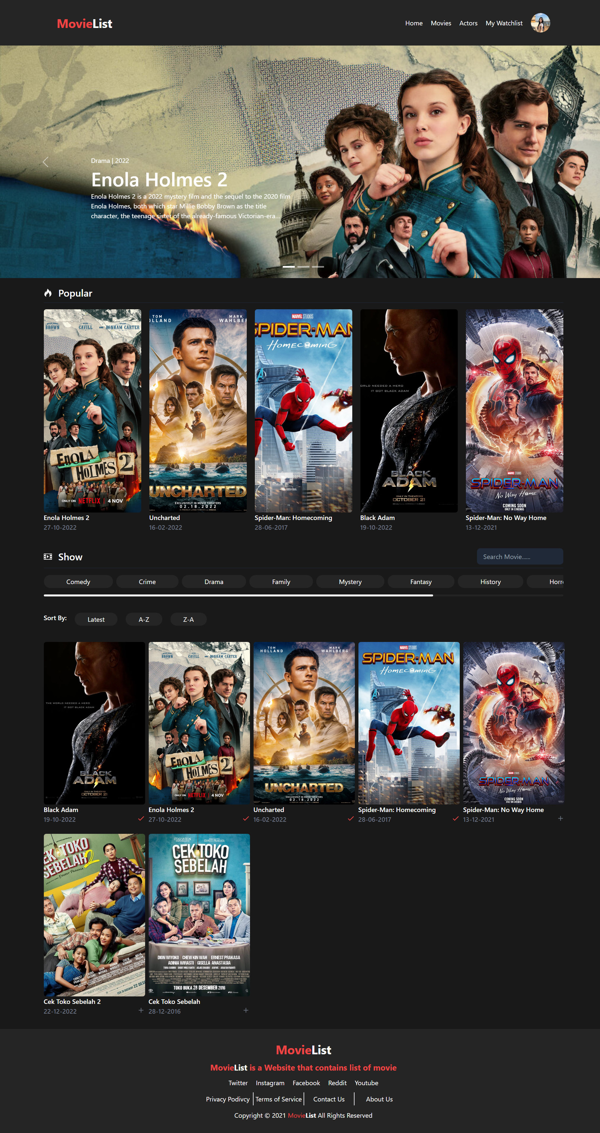

* 1. Admin

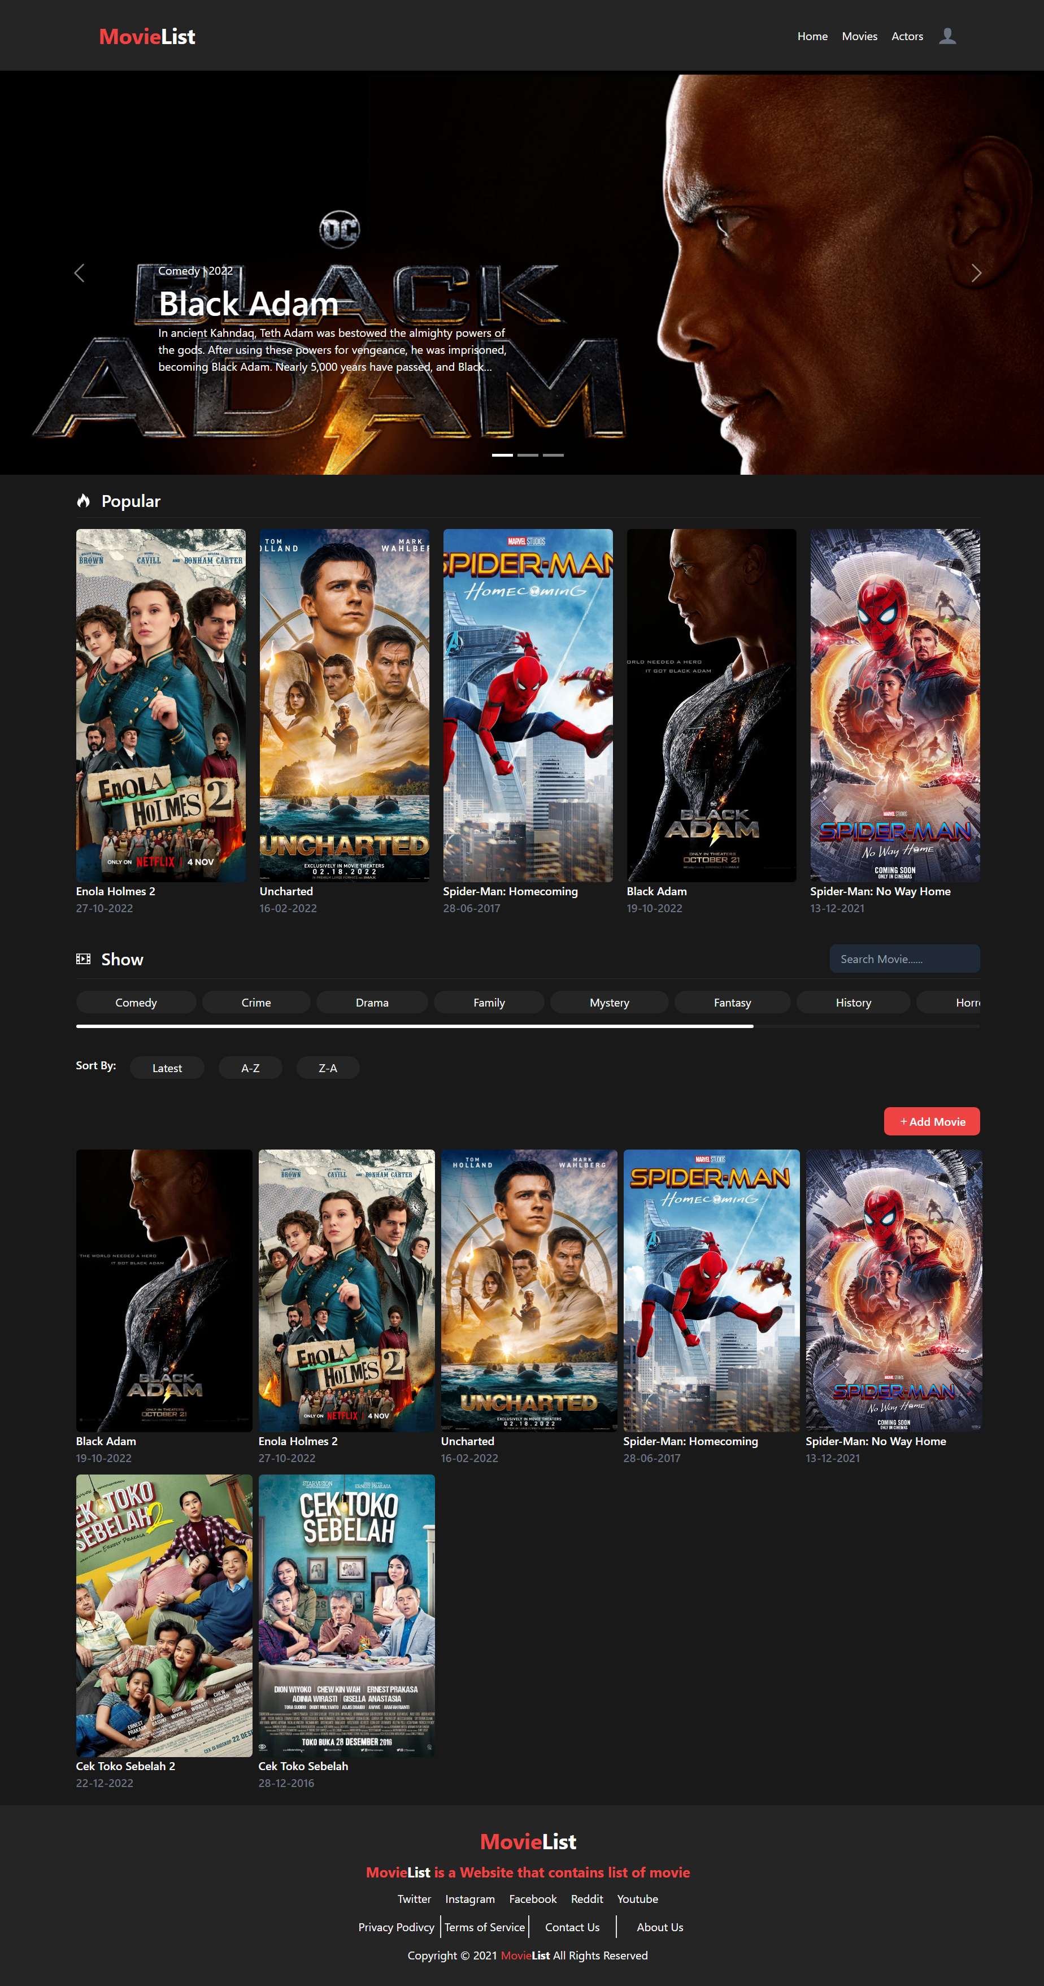

1. Create Movie Page

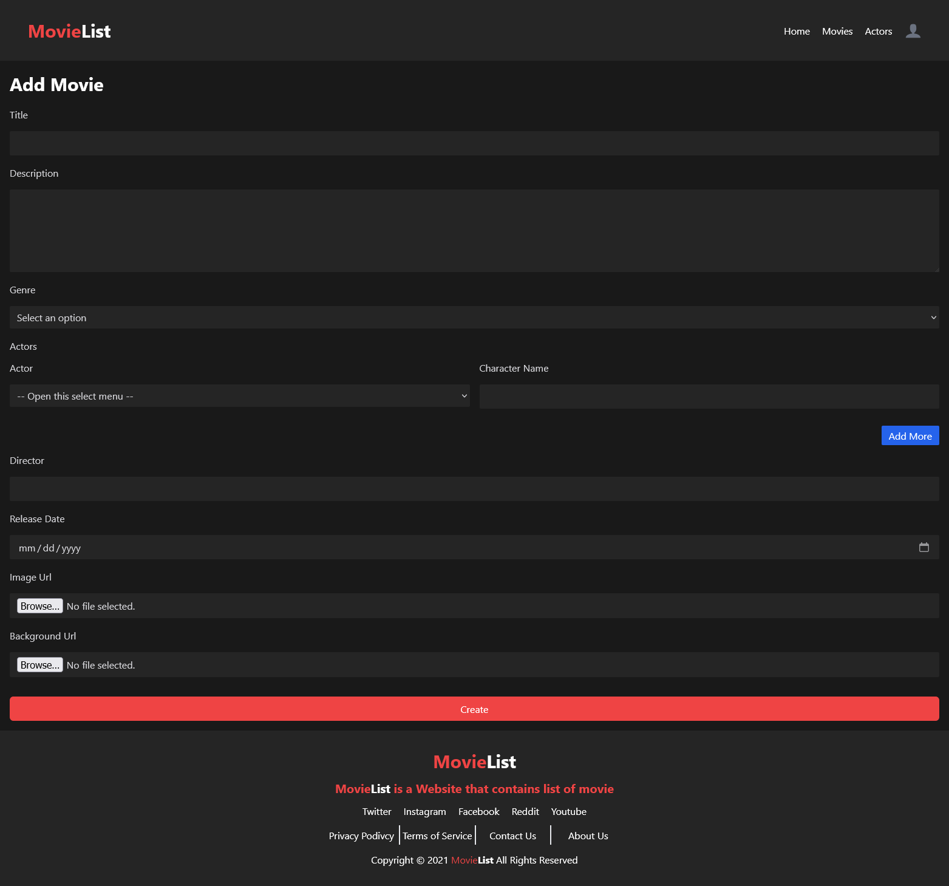

1. Edit Movie Page

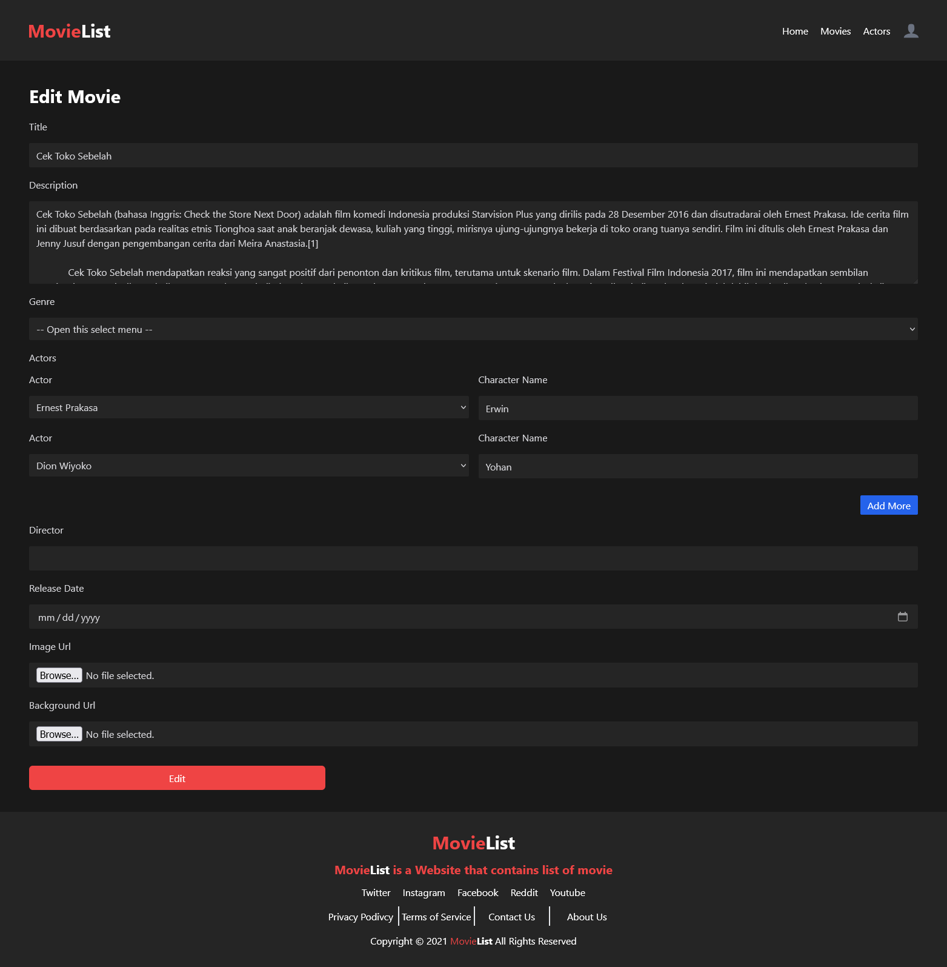

1. Movie Detail Page

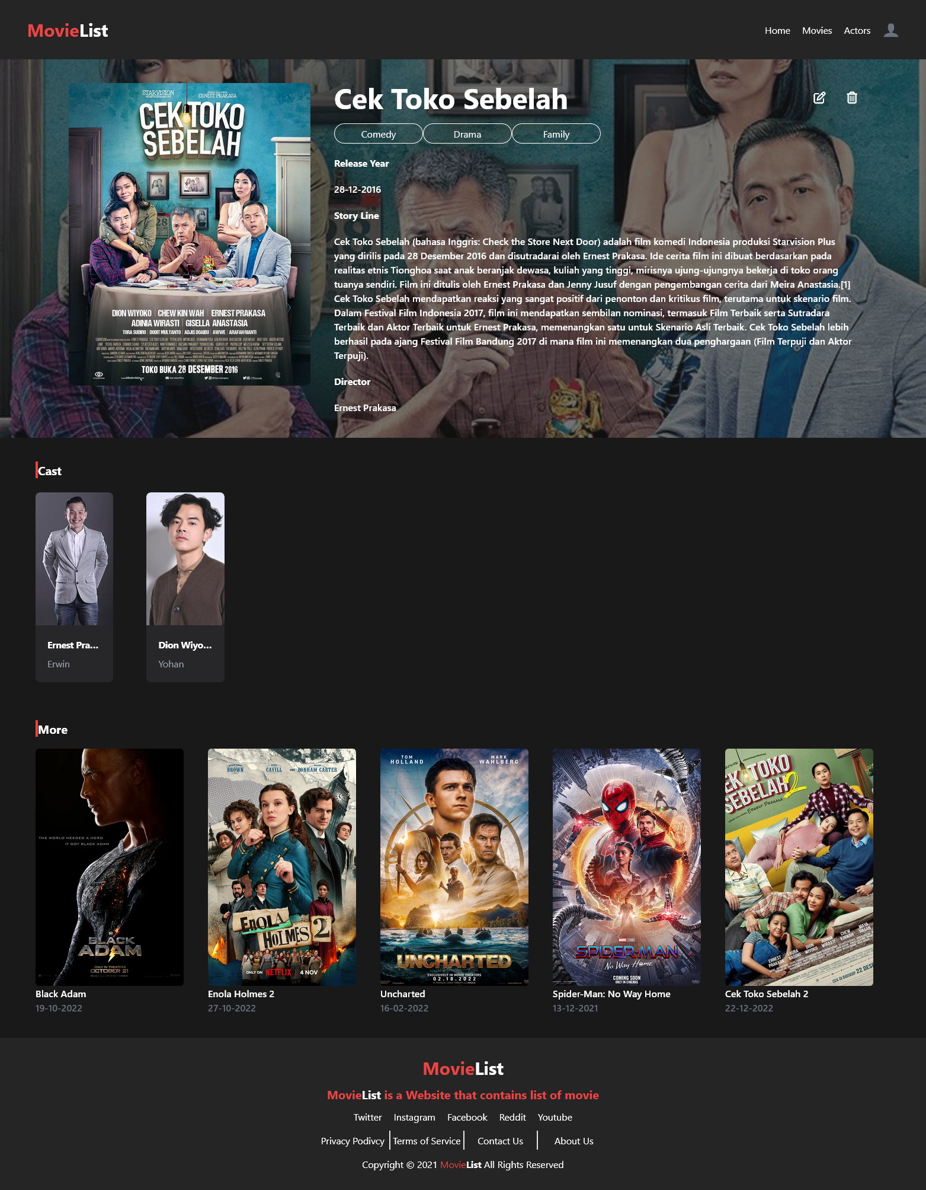

1. Actor Page
   1. Guest and User



* 1. Admin

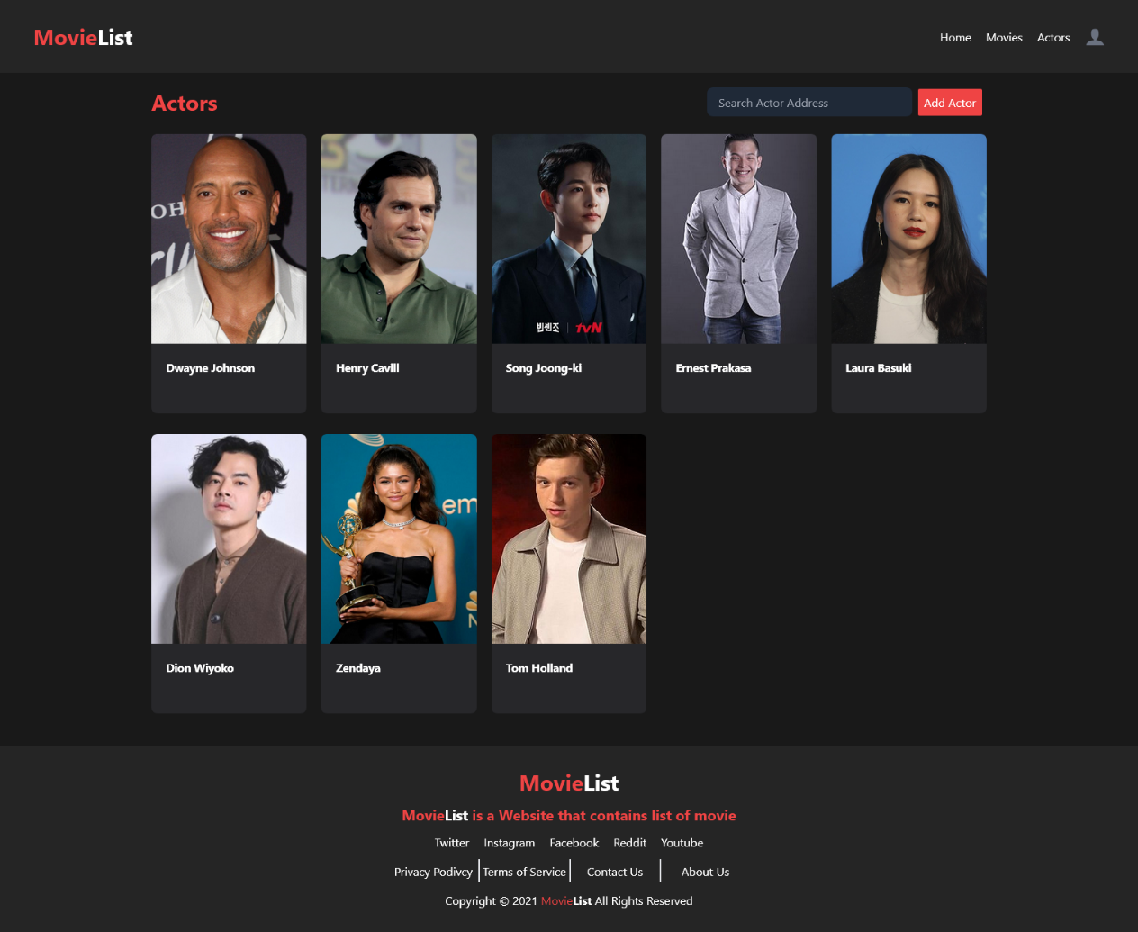

1. Actor Detail Page
   1. Guest and User

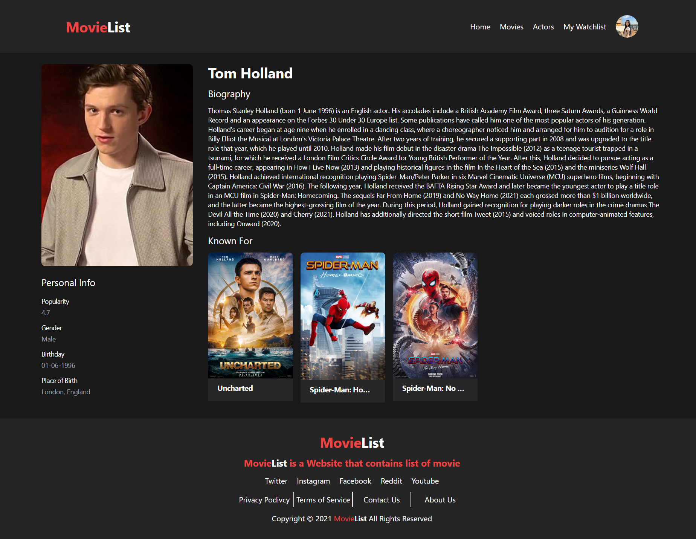

* 1. Admin

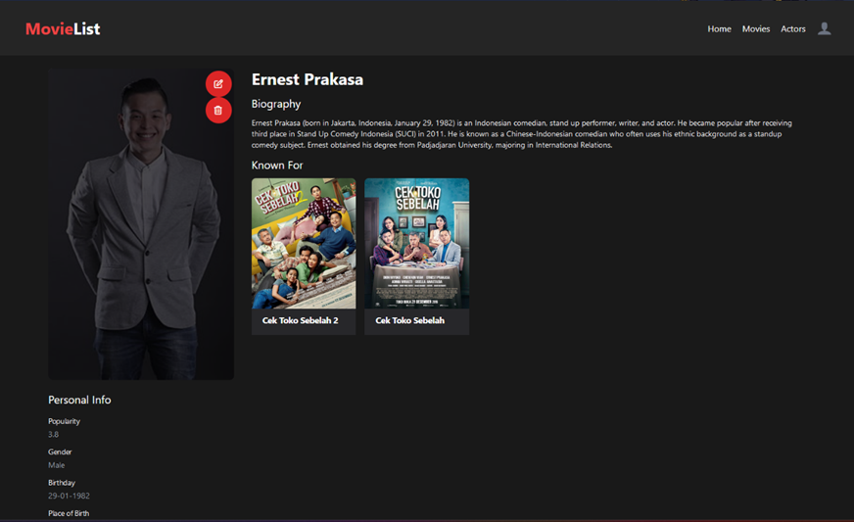

1. Create Actor Page

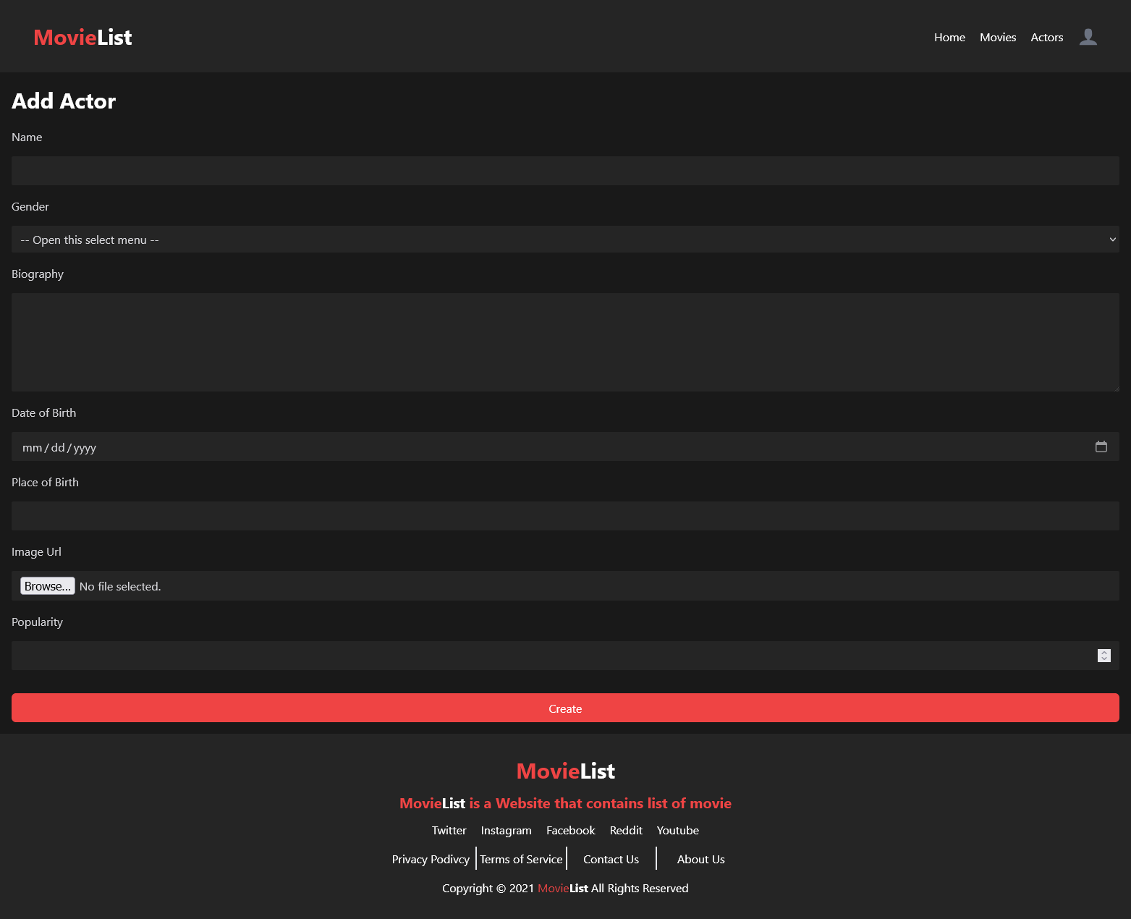

1. Edit Actor Page

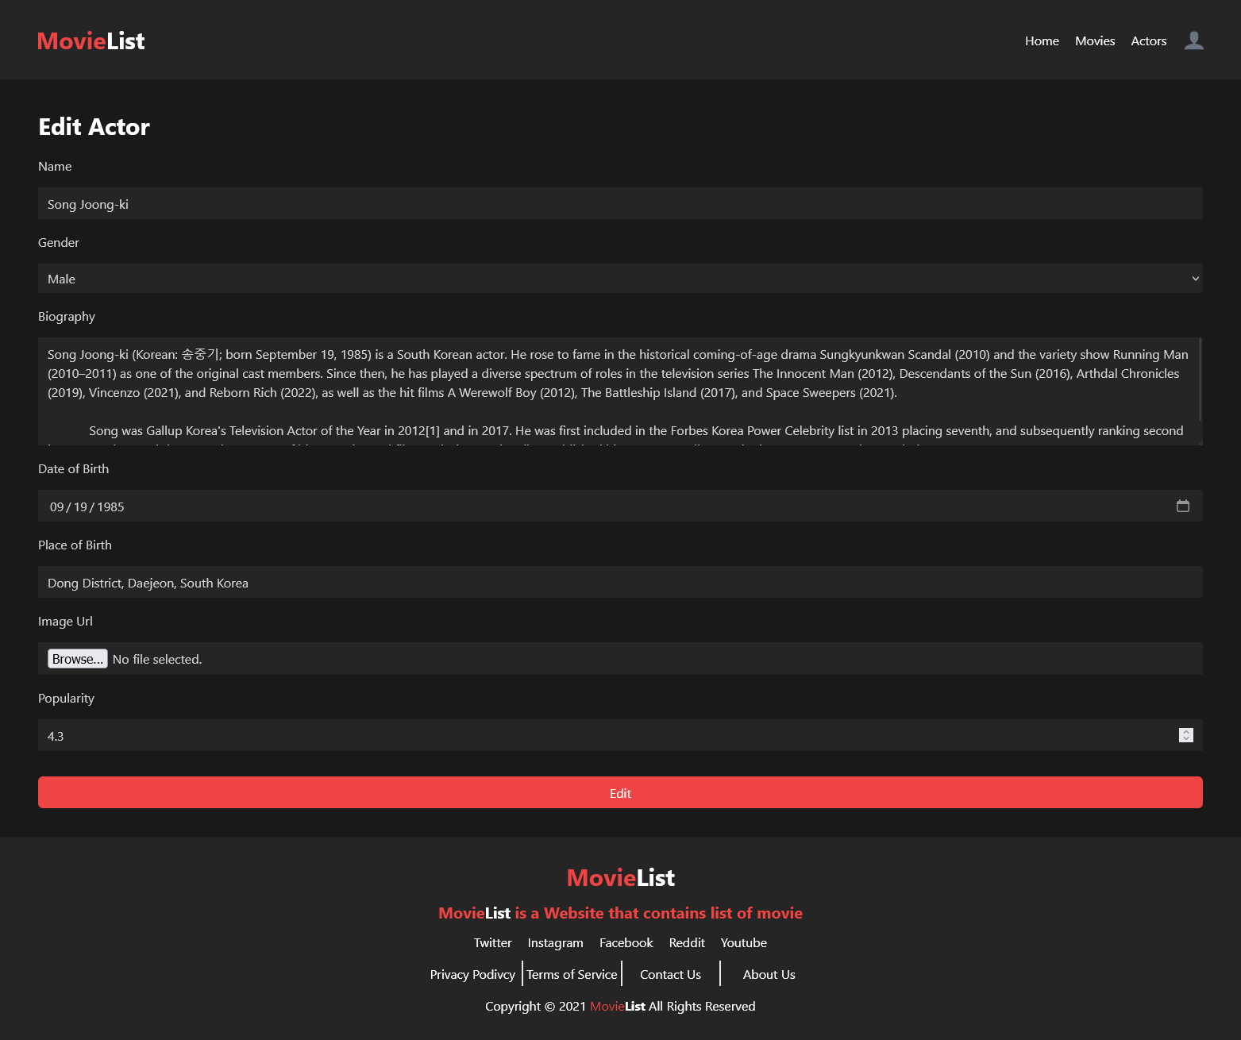

1. Profile Page

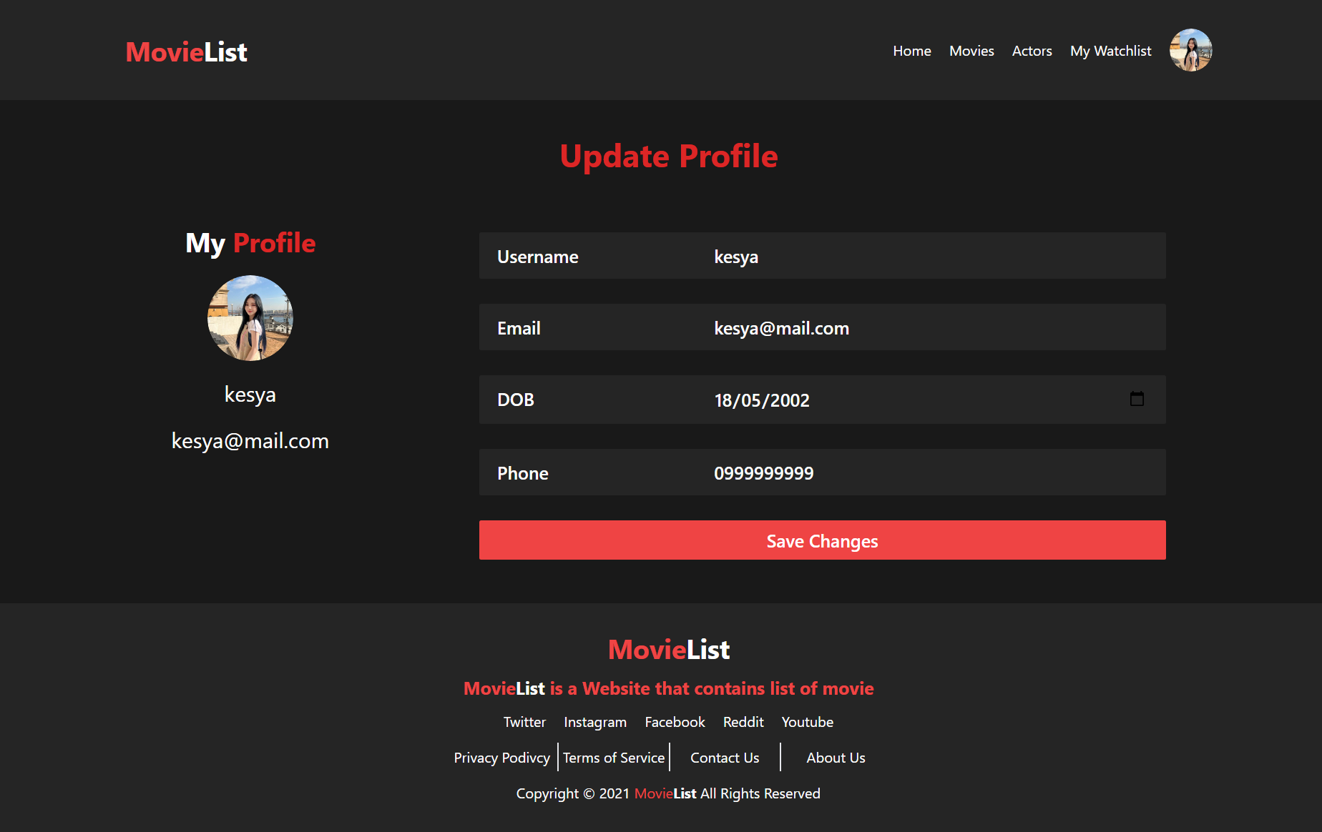

1. Watchlist Page

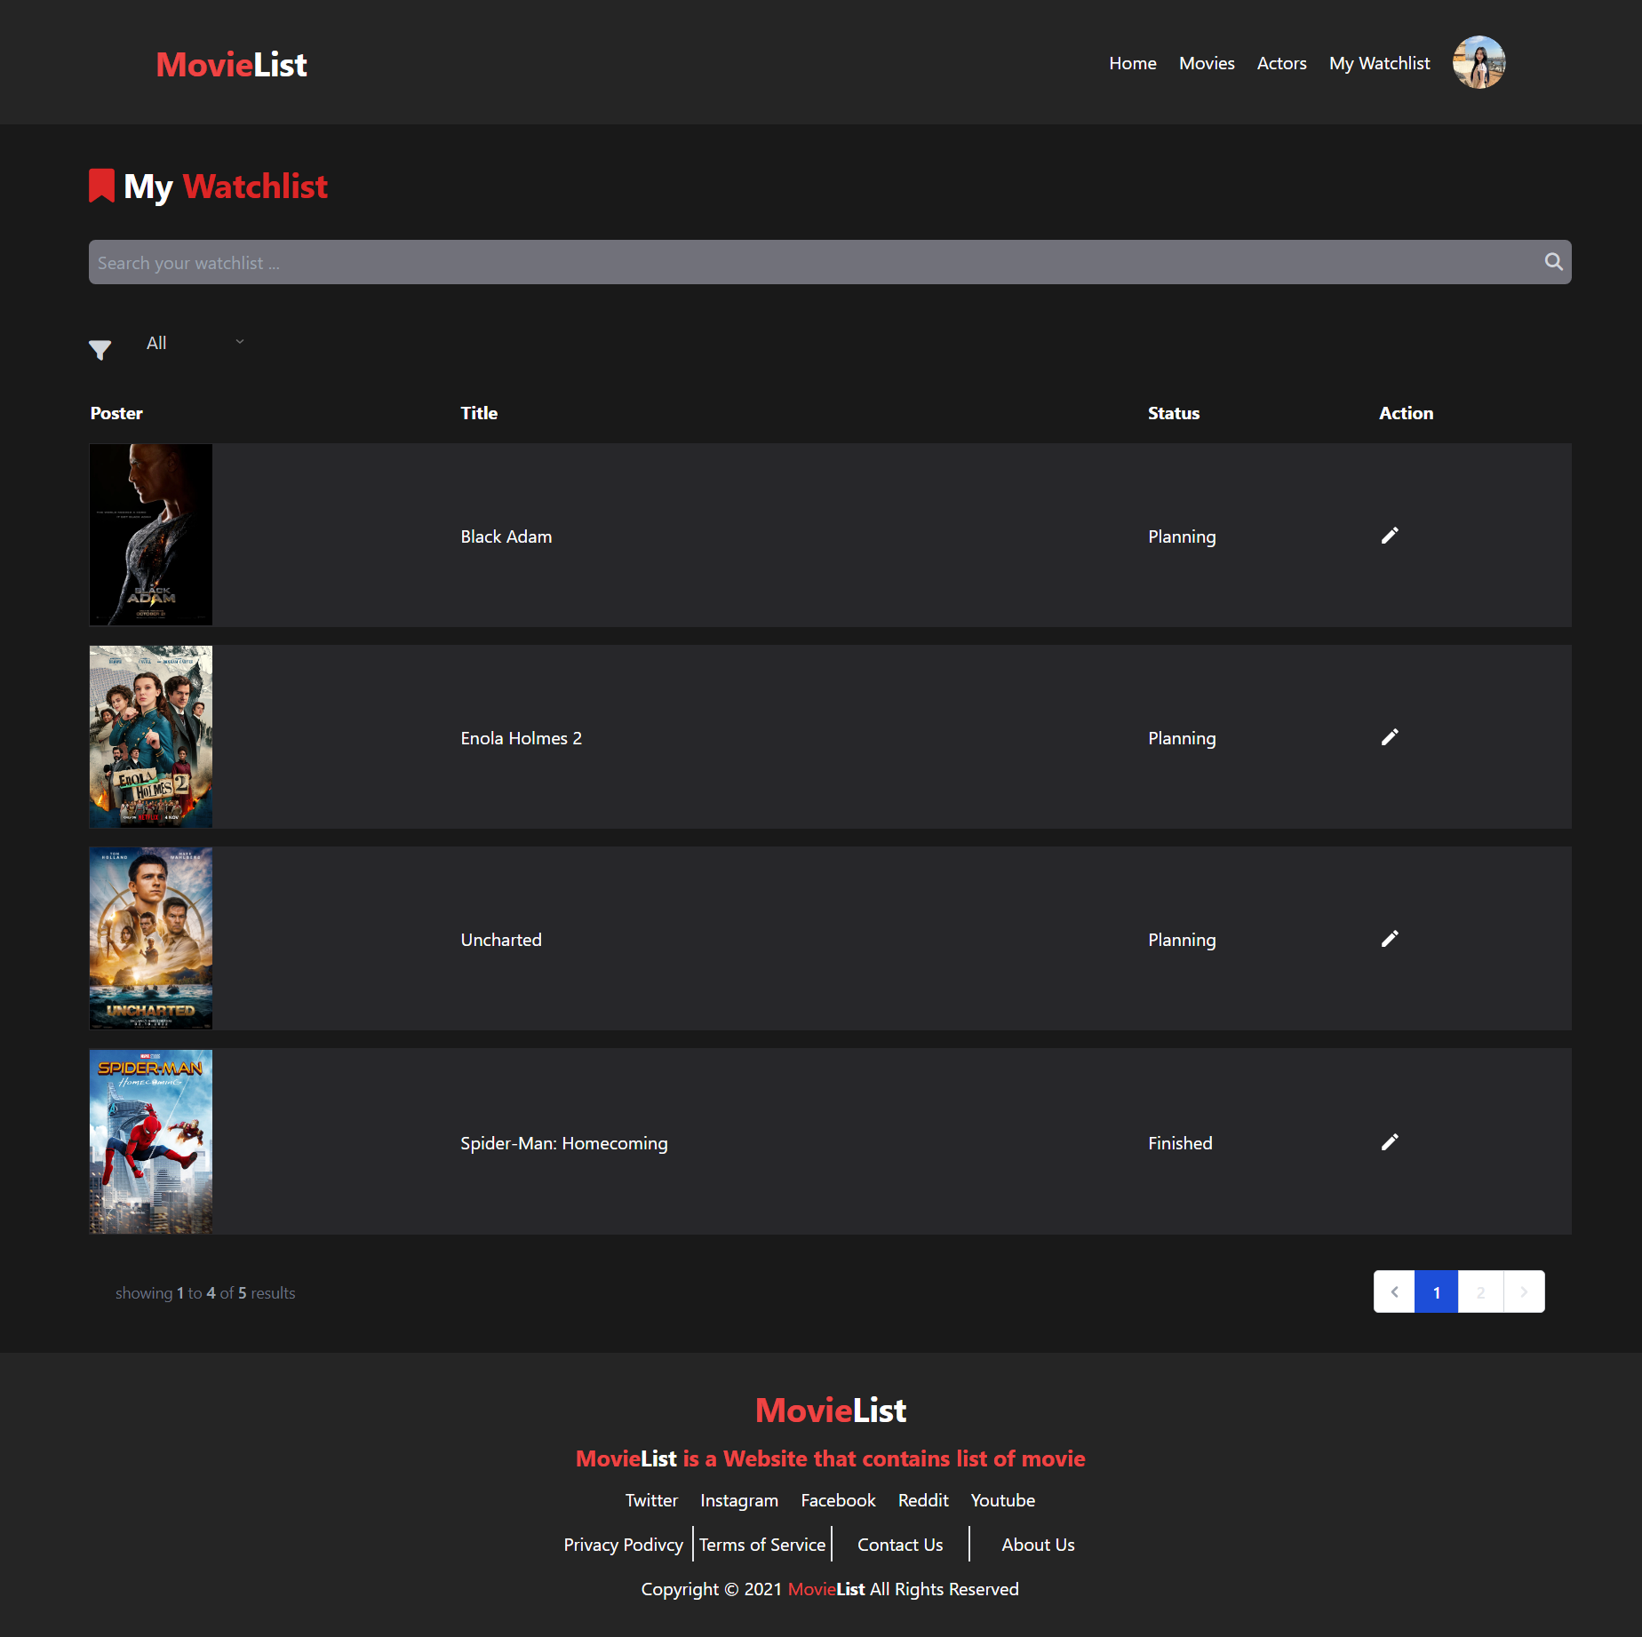

1. Navbar Dropdown
   1. Guest



* 1. User

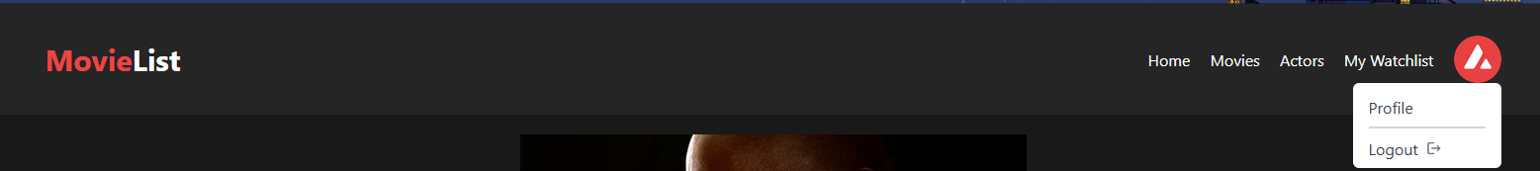

* 1. Admin



* Reference
* Link / References
* Link / References
* ETC
* Group Member
* 2440021426 – Kesya Amanda Wijaya
* 2440007485 – Frisco Lieyanto